**NAME---HARSH KUMAR**

**ID---B219027**

**BRANCH---CE-4TH SEM.**

**DATE--- 12-02-2021**

LAB-5

**1. NOT NULL:** When a column is defined as NOTNULL, then that column becomes a mandatory

column. It implies that a value must be entered into the column if the record is to be accepted for

storage in the table.

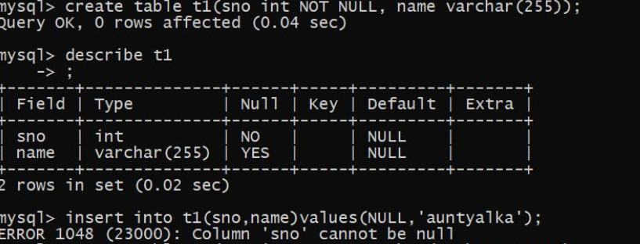

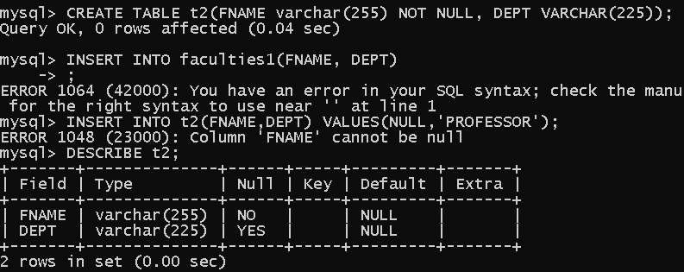

**2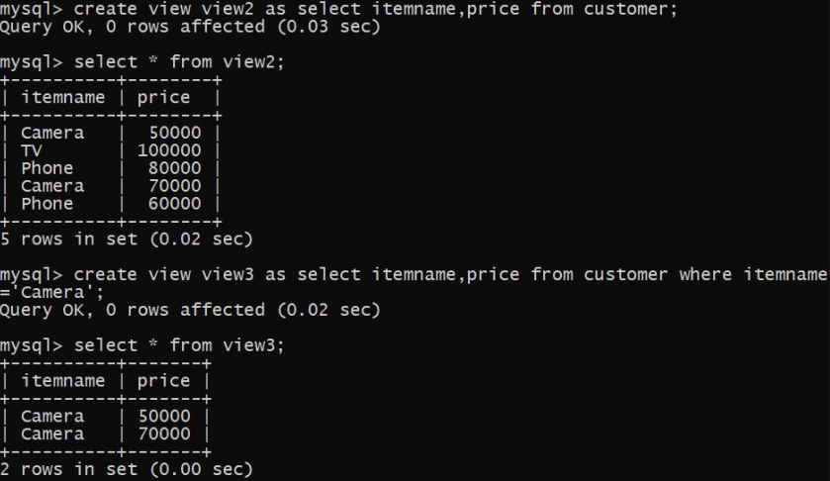. VIEW:** In SQL, a view is a virtual table based on the result-set of an SQL statement. A view contains rows and columns, just like a real table. The fields in a view are fields from one or more real tables in the database. You can add SQL functions, WHERE, and JOIN statements to a view and present the data as if the data were coming from one single table.

**3. DROP VIEW:** This query is used to delete a view , which has been already created.

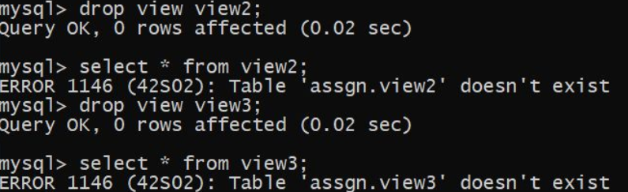

**4. Date functions**: Gives Current date and time.

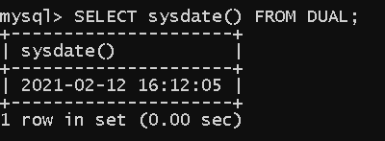

**5. CONCAT:** The CONCAT function converts all arguments to the string type before concatenating. If

any argument is NULL, the CONCAT function returns a NULL value.

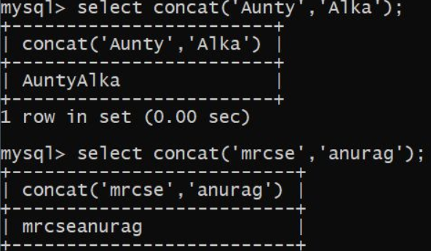

**6. Substr:** Returns part of a character, binary, text, or image expression.

